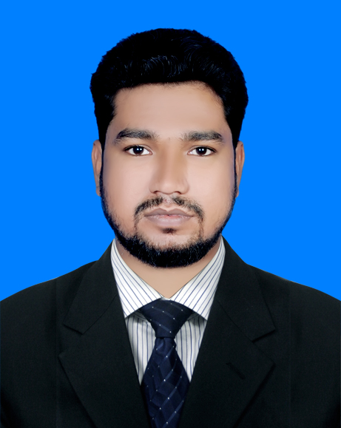
MD : Ikbal Hossain

Phone : 01950758712
E-mail : ikbalbd1052@gmail.com
LinkedIn : https://www.linkedin.com/in/ikbal-hossain-276311148/
GitHub : https://github.com/Ikbal01856226840

Career  Objective | Higher Education strides computer science and engineering Build up career. Good decision-making individual with engineering skills and experience. Coming with the record of making effective decisions on difficult situations that arise.
Esteem  Traits | A drive to perform, patience, accepting challenging work, willingness to learn. I am a hardworking and honest person.
Education | Bachelor of Science (B.Sc).  Higher Secondary School Certificate (H.S.C).  Secondary School Certificate (S.S.C).
  University | Bangladesh University
  Department | Computer science and engineering
  Institution | Bangladesh University, Dhaka. Mohammadpur -1207
  Result | First Class
  Passing Year | 2019
  Institution | Shashidul Alhaj Md. Abutaher College, Brahmanpara, Comilla.
  Group | Science
  Result | 4.33
  Passing Year | 2015
  Board | Comilla
  Institution | Shar-E-Bangla High School  Brahmanbaria, kasba.
  Group | Science
  Result | 4.63
  Passing Year | 2013
  Board | Comilla
Language Proficiency | Fluent of reading and writing in both of Bengali & English language.
Computer Skills  Personal  Project | - System Engineer (Computer Network & System).  - Cisco Certified Network Associate - 200-301 (CCNA).  - Red Hat Certified System Administrator (RHCSA).  - Red Hat Certified Engineer (RHCE).  - Hardening Red Hat Linux (IPA Server).  - Red Hat SSH-KEYGEN High Security.  - MikroTik Certified Network Associate (MTCNA)  - Graphics Design.  - Web Design and Development.  - Computer Hardware Troubleshooting.  Personal Project  - Online Exam Management System.  - Library Management System.  - Inventory Management System.
Personal information | Name : MD.Ikbal Hossain  Father’s Name : Md. Babul Hossain  Mother’s Name : Shahena Begum  Date of Birth : 15-11-1996  Nationality : Bangladeshi  Religion : Islam  Sex : Male  Marital Status : Unmarried  Height : 5’-4’’  Phone No : 01950758712
Present Address | C/O : MD.Ikbal Hossain  VILL : DhakaUddan  P.O : Mohammadpur-1207  P.S : Mohammadpur  DIST : Dhaka
Permanent Address | C/O : MD.Ikbal Hossain  VILL : Khullaputer  P.O : Kasba  P.S : Biddanoger  DIST : Brahmanbaria
Reference | I hereby declare myself that all the statement in this CV are authentic Complete and Correct to the best of my knowledge.  Yours truly,  Md. Ikbal Hossain Date: 03-12-2021

